Name: School:

What do you want?

- From this networking session…

- From future networking sessions…

- From Broxtowe Active Schools (particularly from September 2020 onwards)…

- From the wider network / general support and advice…

Does your school have?
- A school sports organising Crew?

- Sports leaders?

- A Change4Life club (or any targeted clubs) for 6 weeks or more?
- If so: Approx. number of participants: Number of young leaders:

Active Schools Action Planning
School:
Understanding the benefits of an active school?
- PE/Sport Lead?
- Headteacher?
- Governors?
- Parents?
- Pupils?

Establish current active school levels (www.activeschoolplanner.org or similar)
- Completed a mapping activity for one class?
- Completed a mapping activity for every child?

What are the links to your whole school priorities?

Actions:
1.
2.

Support requested:

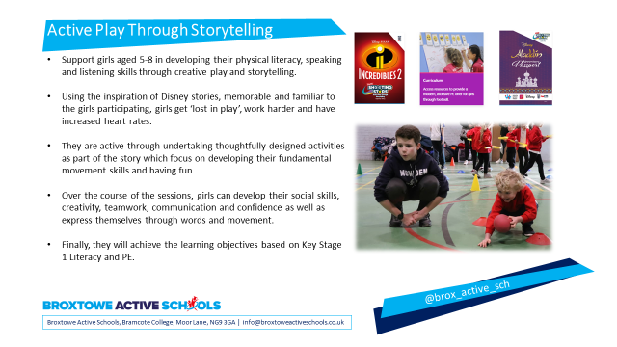

Register on www.girlsfootballinschools.org, complete baseline survey as soon as possible.
Receive access to courses and resources. (After school clubs, Active Play, FA Primary Teachers award)
Register at www.activeschoolplanner.org and complete heatmapping.
Register at www.yourschoolgames.com for access to resources, games mark, enter school events and more.
Sign your school up for stand-up Notts on the 5th June 2020.

School | PE/Sport Contact | Head Teacher Name & Email | Chair/Sports Governor Name/Email | SENCO Name / Email

